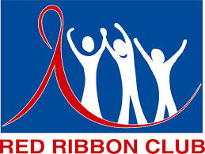
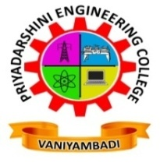

PRIYADARSHINI ENGINEERING COLLEGE

(Approved by AICTE, New Delhi and Affiliated to Anna University, Chennai)
Chettiyappanur, Vaniyambadi, Vellore District, Tamil Nadu - 635751
Ph: 04174-227591. www.priyadarshini.net.in

principal@priyadarshini.net.in

YRC / RRC

REGULAR ACTIVITIES 2018 – 19
S.No | Activities | Date and Venue | Chief Guest / Other Associated Institution Details
1 | International Yoga Day | 21.06.2018 / College Auditorium | Mr.Arumugam,  Krish Yoga,  Vaniyambadi.
2 | International Day against Drug Abuse and Illicit Trafficking | 26.06.2018 / By – Pass Road Vaniyambadi | Principal, All HOD’S and Staffs, PEC.
3 | World Population Day | 11.07.2018 / College Auditorium | Mr.A.David Subash Chandran, Karunai illam, Vaniyambadi
4 | Celebrating Life - HIV / AIDS Awareness | 25.07.2018 / College Auditorium | Dr.A.SWEETHA, MBBS,  ART Medical Officer,  GH, Tirupattur.
5 | College Campus Cleaning | 13.08.2018 / Campus Cleaning | YRC / NSS Coordinator & Students.
6 | Anti-ragging Awareness Programme | 26.09.2018 / College Auditorium | Thiru. S.Ramachandiran,  Subordinate Judge, Chairman-Taluk Legal, Vaniyambadi.
7 | Awareness Programme on Enrollment of Electoral Roll | 29.09.2018 / College Auditorium | Mr.Jayaprakash, Deputy Collector, Mrs.Krishanaveni  Tahsildar, Ms.Sangeetha Deputy Tahsildar, Vaniyambadi.
8 | Blood Donation Camp | 10.10.2018 / PEC Vaniyambadi | GH Doctors, Vaniyambadi.
REGULAR ACTIVITIES 2017 – 18
S.No | Activities | Date and Venue | Chief Guest / Other Associated Institution Details
1 | Blood Donation Camp | 27.07.2017 / PEC Vaniyambadi | Vaniyambadi GH Doctors,
2 | Tree Plantation – Death Anniversary of Dr.A.P.J.Abdul Kalam | 27.07.2017 / PEC Vaniyambadi | Rotaract Club, Vaniyambadi.
3 | Interview Process and Motivation Skills | 19.08.2017 / College Auditorium | Mr.A.G.Sivakalaivanan, Vellore.
4 | Tree Plantation - First Year Induction Day | 12.09.2017 / PEC Vaniyambadi | Sub Collector, Tirupattur.
5 | Celebrating Life | 03.02.2018 / PEC Vaniyambadi | Mr.K.Athisaya Ruban, RRC District Manager, Vellore.
6 | Disaster Management | 20.02.2018 / PEC Vaniyambadi | Mr. G.Arumugam, Training Officer, South Regional, India National Disaster Management Authority (Govt of India), New Delhi
7 | Blood Donation Camp | 06.03.2018 / PEC Vaniyambadi | Dr.Ambika,MBBS.,GH, Vaniyambadi.
REGULAR ACTIVITIES 2016 – 17
S.No | Activities | Date and Venue | Chief Guest / Other Associated Institution Details
1 | Tree Plantation | 04.08.2016 / PEC Vaniyambadi | First Year B.E Fresher’s.
2 | 70th Independence Day - Competition | 12.08.2016 / College Auditorium | All HOD’S, PEC.
3 | Career Prospects of Engineering Graduates – Guest Lecture | 17.09.2016 / College Auditorium | Prof.S.Uma, Thiruvallauvar University, Tirupattur.
4 | Blood Donation Camp | 24.01.2017 / PEC Vaniyambadi | Dr.Ambika,MBBS.,GH, Vaniyambadi.
5 | Voter’s Pledge | 25.01.2017 PEC Vaniyambadi | All Staff’s and Students.
6 | Factors that Cause Mental Stress and the Medical Remedy for the Same – Guest Lecture | 01.02.2017 / College Auditorium | Dr.R.ARIVUMANI, MBBS, Government Hospital, Vaniyambadi
7 | Blood Donors Club | 24.02.2017 / College Auditorium | Rotary Club, Vaniyambadi.
8 | One Day Disaster Management Training Programme | 07.03.2017 / College Auditorium | Mr.A.David Subash Chandran, Mr.G. Suresh and Mr.K.Kumareswaran
9 | Vasan Eye Care - Screening Camp | 11.03.2017 / College Auditorium | Doctors, Vasan Eye Care.
REGULAR ACTIVITIES 2015 – 16
S.No | Activities | Date and Venue | Chief Guest / Other Associated Institution Details
1 | Tree Plantation | 03.08.2015 / PEC Vaniyambadi | First Year B.E Fresher’s.
2 | International Youth Day Pledge | 12.08.2015 / College Auditorium | All Staff’s and Students.
3 | Blood Donation Camp | 26.08.2015 / PEC Vaniyambadi | Dr.Ambika,MBBS.,GH, Vaniyambadi.
4 | Blood Donation Camp | 19.02.2016 / PEC Vaniyambadi | Dr.Ambika,MBBS.,GH, Vaniyambadi.
5 | Youth Suicide Prevention | 19.03.2016 / College Auditorium | Mr.R.Selvakumar and Mr.J.Elangovan , Sneha India Volunteers, Chennai.
6 | Disaster Management – Guest Lecture | 25.04.2016 / College Auditorium | Mr.S.N.Janardhanan, Vocational Teacher, Govt(G) School, Vellore.
REGULAR ACTIVITIES 2014 – 15
S.No | Activities | Date and Venue | Chief Guest / Other Associated Institution Details
1 | Blood Donation Camp | 06.08.2014 / PEC Vaniyambadi | Dr.Ambika,MBBS.,GH, Vaniyambadi.
2 | National Blood Donation Day and Communal Harmony Day Celebration | 02.10.2014 / College Auditorium | All HOD’S, PEC.
3 | National Voter’s Day | 21.01.2015 / College Auditorium | All HOD’S, PEC.
4 | Voter’s Day Celebration | 13.02.2015 / College Auditorium | Vaniyambadi Tahsildar.
5 | World Health Care and Safety Day Celebration | 08.04.2015 / College Auditorium | Rotary Club, Vaniyambadi.
6 | Entry of AADHAAR Number in Voter ID | 10.04.2015 / College Auditorium | YRC/NSS Coordinator & Students.
7 | Medical Camp and Health Awareness Camp | 28.04.2015 / College Auditorium | Ekam foundation at Vaniyambadi.
REGULAR ACTIVITIES 2013 – 14
S.No | Activities | Date and Venue | Chief Guest / Other Associated Institution Details
1 | General Free Medical Camp | 07.08.2013 / PEC Vaniyambadi | Dr.Ambika,MBBS.,GH, Vaniyambadi
2 | Special Medical Camp for Girl’s Student | 11.10.2013 / PEC Vaniyambadi | Dr.Ambika,MBBS.,GH, Vaniyambadi
3 | Guinness Record of Blood Donation Camp | 20.02.2014 / Nethaji Studium, Vellore | Vellore collector
4 | Peer Education Training Programme | 26.02.2014 / BEC Nattrampalli | YRC Coordinator, BEC
5 | AIDS Awareness Camp – Guest Lecture | 07.03.2014 / College Auditorium | Mr.K.Athisaya Ruban, Vellore
6 | Road Safety Awareness Programme | 19.03.2014 / College Auditorium | Mr.Ranganathan, Motor Vehicle Inspector, RTO Office, Vaniyambadi.
7 | Blood Donation Camp | 03.04.2014 / College Auditorium | Dr.Ambika,MBBS.,GH, Vaniyambadi
8 | AIDS Awareness Programme | 17.04.2014 / College Auditorium | All HOD’S, PEC.
PHOTO GALLERY
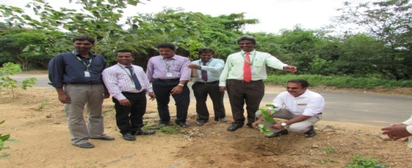
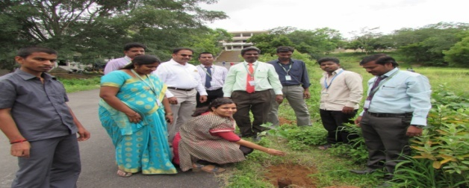
Tree Plantation

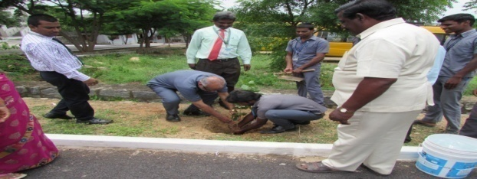
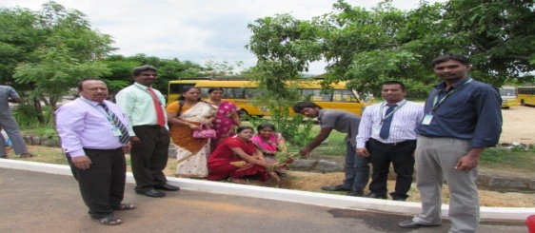
70th Independence Day – Competition
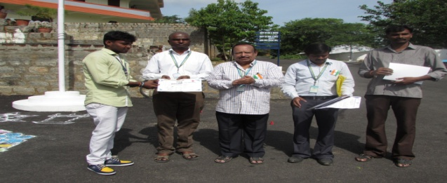
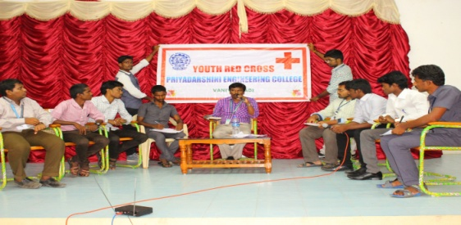

Career Prospects of Engineering Graduates – Guest Lecture
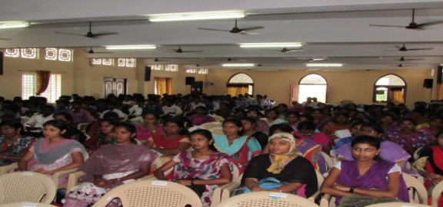
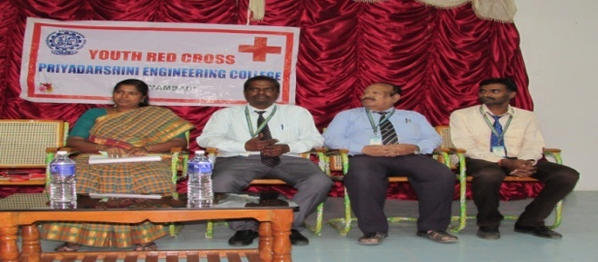

Tree Plantation - First Year Induction Day
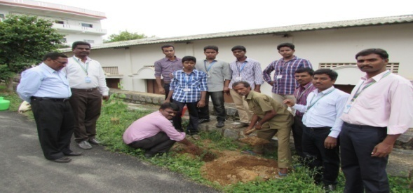
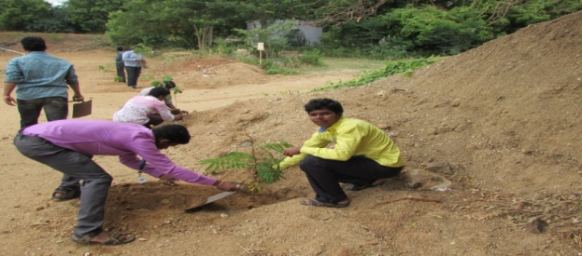

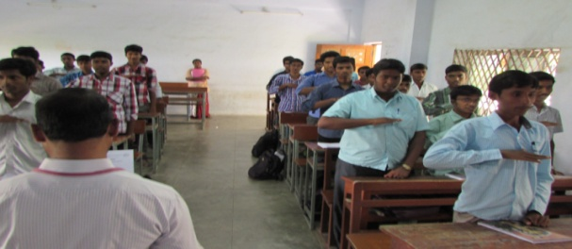
International Youth Day
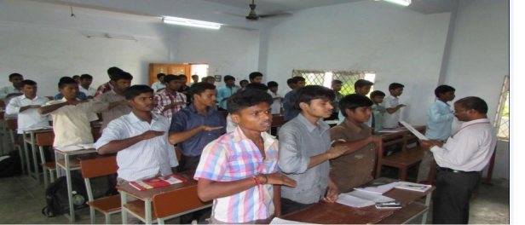

Blood Donation Camp
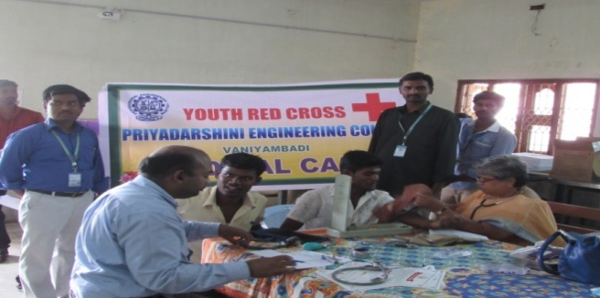
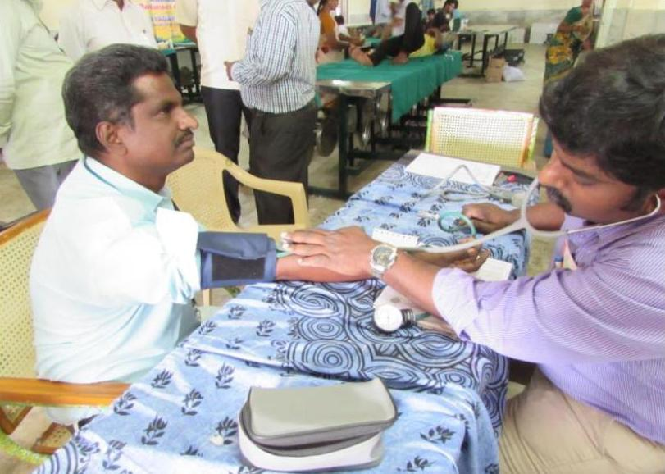

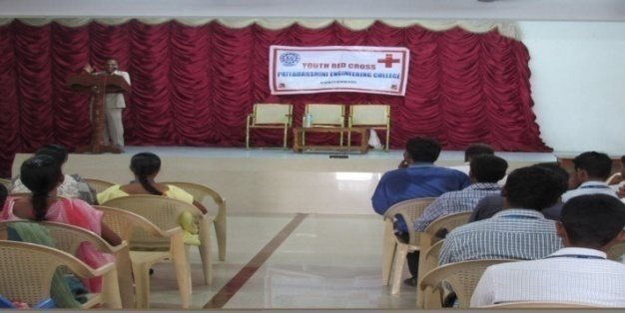
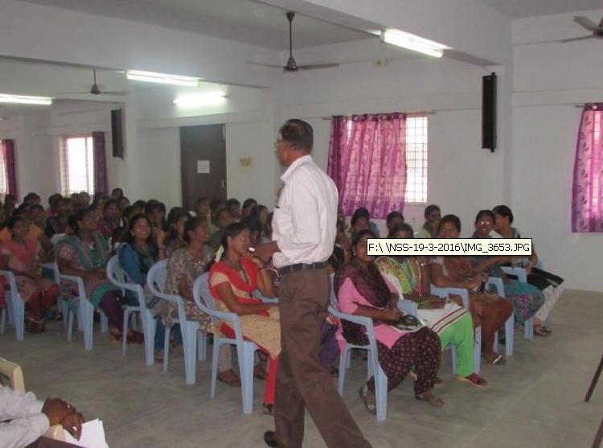
Youth Suicide Prevention Disaster Management –(GL)

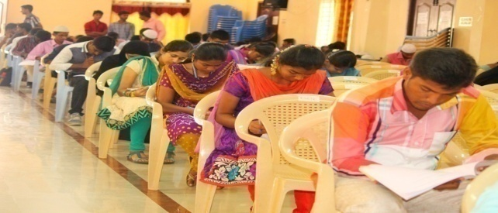
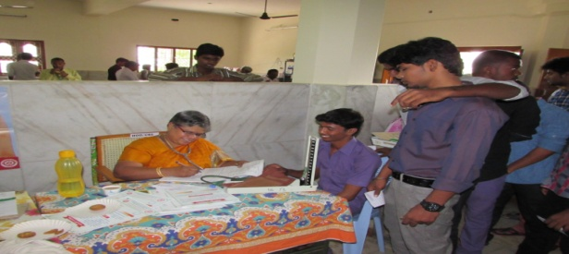
Blood Donation Camp Communal Harmony Day

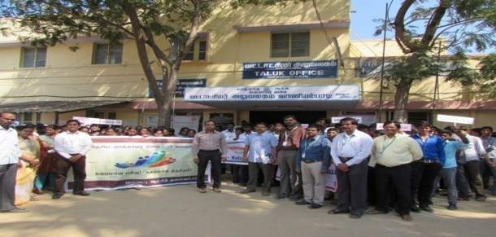
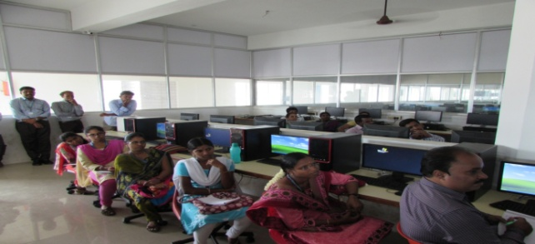
Voter’s Day Celebration Entry Of AADHAAR Number
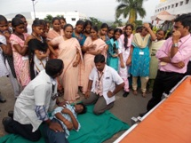
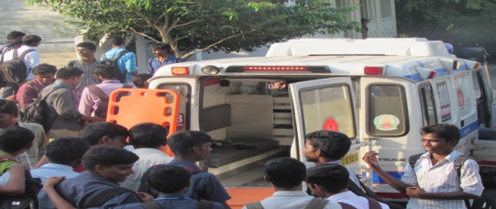
Health Awareness Camp Special Medical Camp for Girl’s Student

Peer Education Training Programme AIDS Awareness Camp (GL)
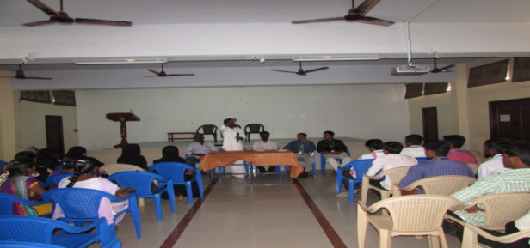
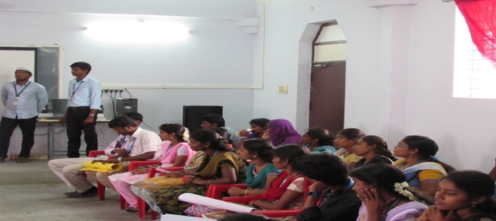

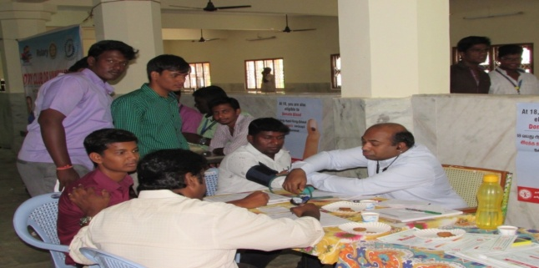
Blood Donation Camp AIDS Awareness Programme
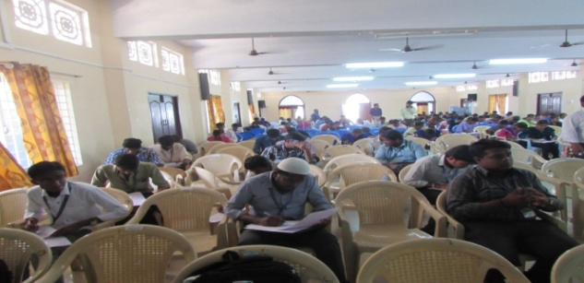

Tree Plantation - Death Anniversary of Dr.A.P.J.Abdul Kalam
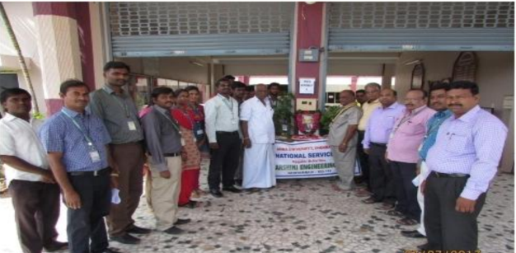
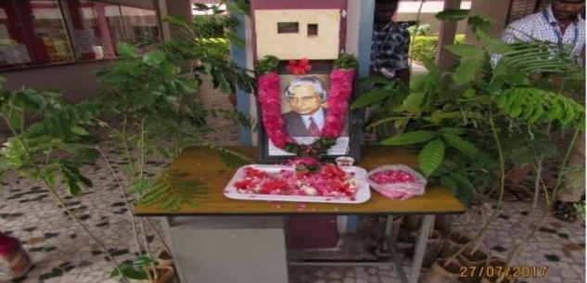

Blood Donation Camp
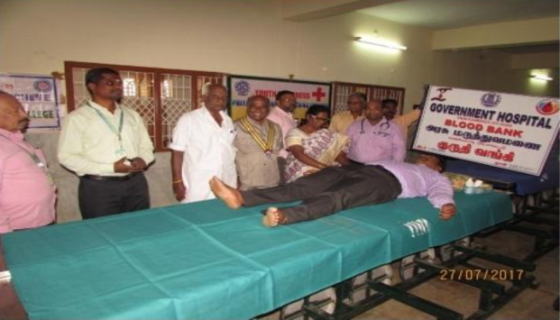
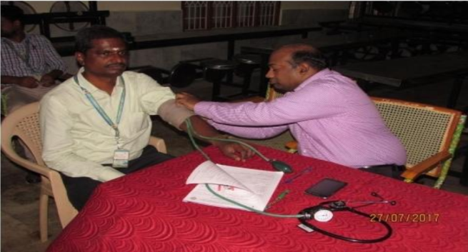

Interview Process and Motivation Skills
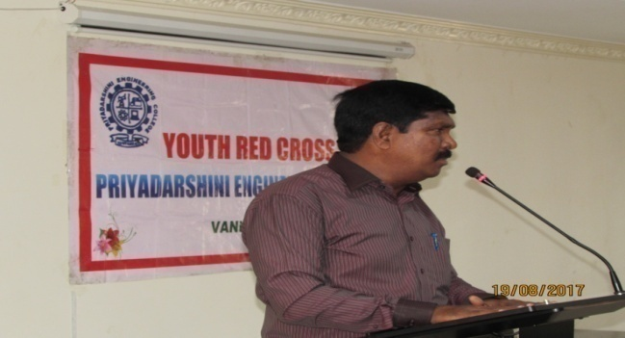
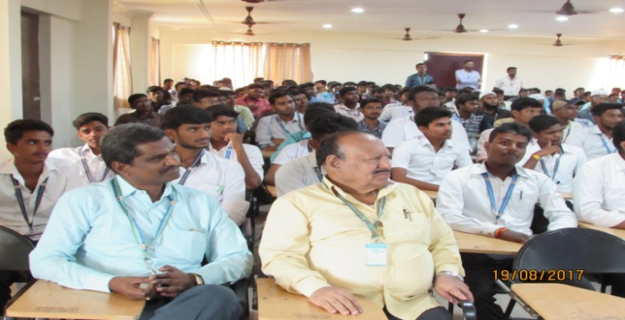

Tree Plantation - First Year Induction Day
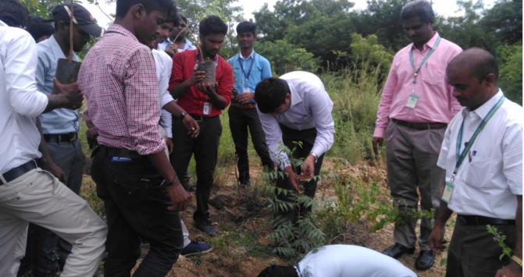
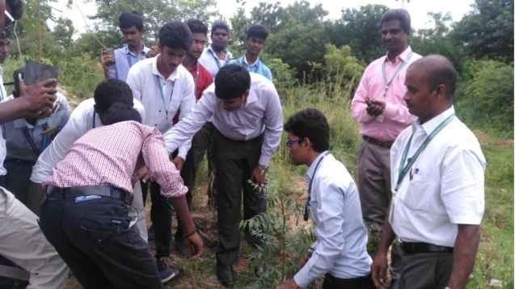

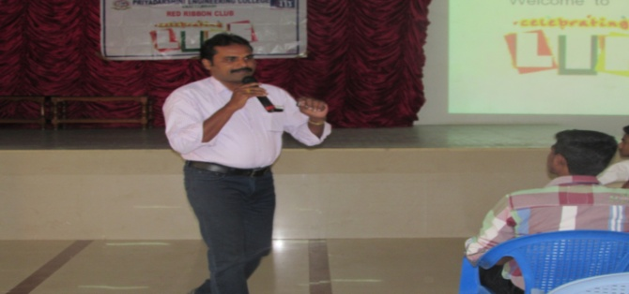
Celebrating Life
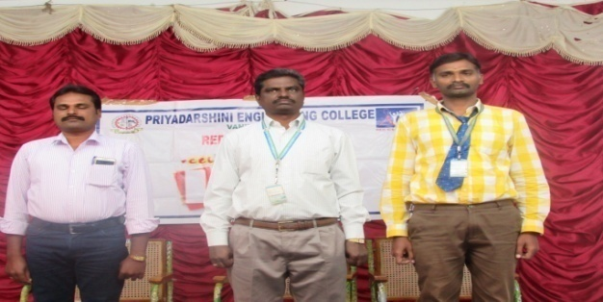
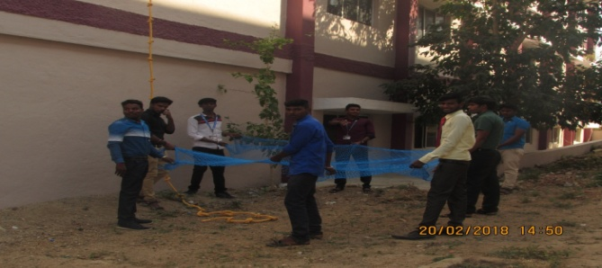
Disaster Management
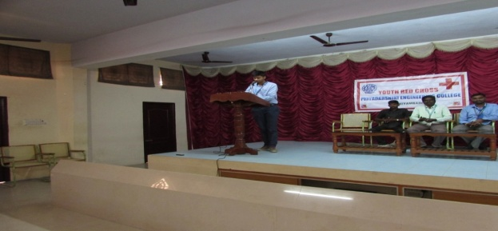
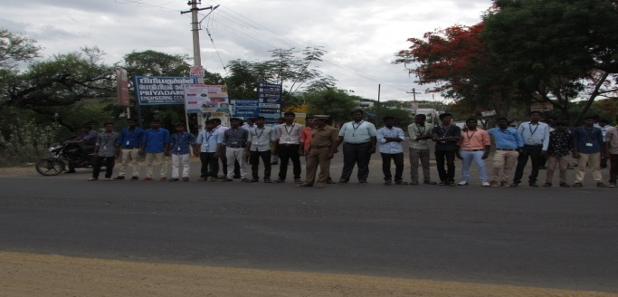
International Day against Drug Abuse and Illicit Trafficking
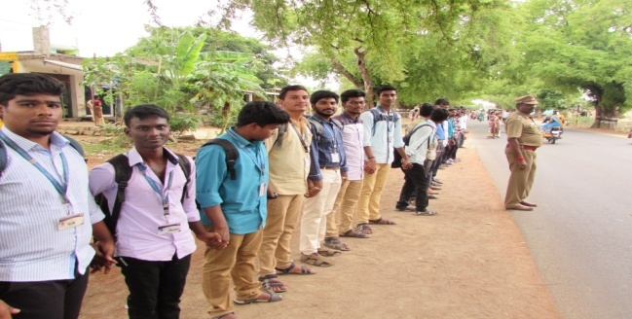
International Yoga Day
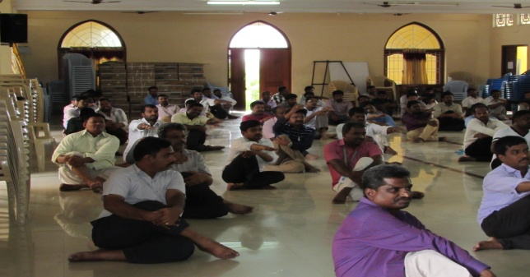
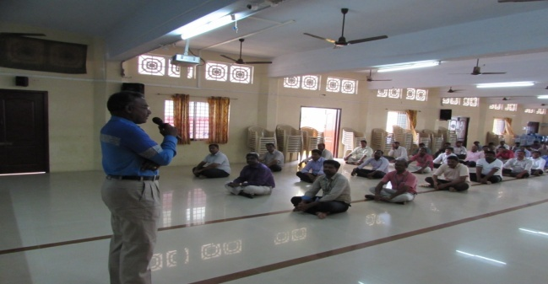

World Population Day
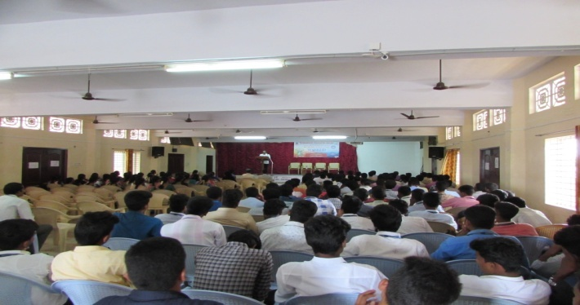
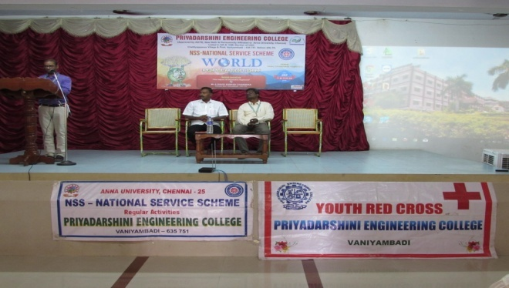
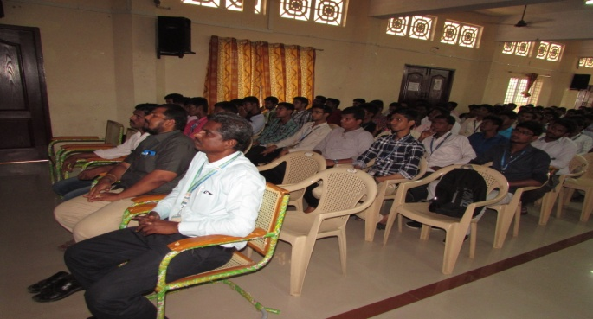
Celebrating Life - HIV / AIDS Awareness
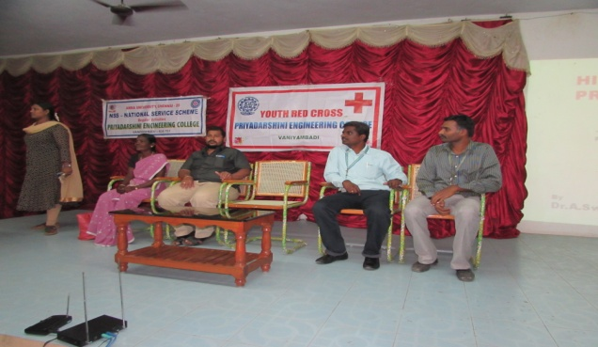
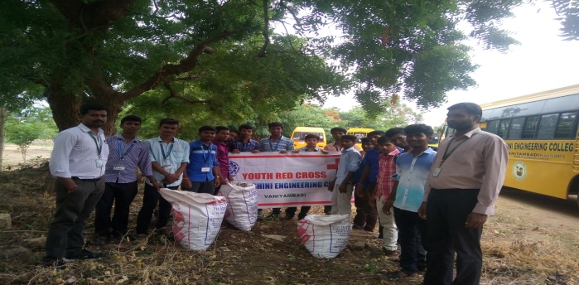
College Campus Cleaning
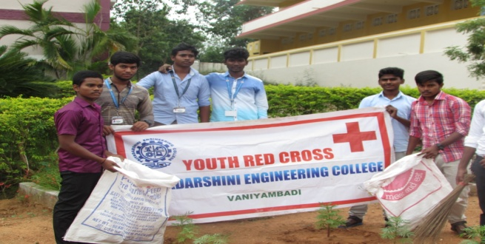
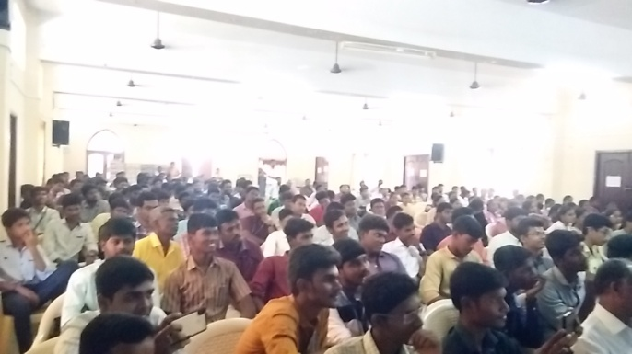
Awareness Programme on Enrollment of Electoral Roll
